From: https://davidstockmanscontracorner.com/no-joy-in-never-trumpville-the-mighty-mueller-has-struck-out-part-2/

Mighty Mueller Has Struck Out, Part 2
By David Stockman. Posted On Monday, April 22nd, 2019
Akin to the proverbial blind squirrel finding an acorn, the Donald sometimes hits the nail on the head--- and this is his mostly deadly strike ever:
How do you impeach a Republican President for a crime that was committed by the Democrats? MAKE AMERICA GREAT AGAIN!
6:35 PM - 21 Apr 2019
Strangely enough, the Mueller Report proves him right. That's because it details systematically and exhaustively the steps taken by the Obama Administration and the Deep State apparatus to investigate the Trump candidacy and presidency. Yet it fails to show even a iota of real proof that anything remotely resembling a national security threat--to say nothing of a crime---was presented by Donald Trump and his campaign.
So that's the real crime, statutory or not. Democrat partisans like John Brennan and the McCabe claque in the FBI had zero justification for mobilizing the instrumentalities of the national security apparatus to block Trump's election.
But they were motivated by such blind partisanship and antipathy to the Trump's inchoate call to end The Empire that they literally turned molehills into mountains to justify their actions. And since then, their assiduously promoted false Russia meddling/collusion story has been repeated with such relentless fervor by the MSM that the actual triviality and irrelevance of the original allegations have been lost amidst the hysteria.
While it was surely not intended, however, the Mueller Report's ostentatiously footnoted narrative shatters this spell of modern day Salem witchcraftery and confirms there never was anything behind the curtain at all with regard to the six elements that comprise the heart of the story:
- Carter Page;
- Baby George Papadopoulos;
- the Trump Tower Meeting;
- the DNC/Podesta email disclosures;
- the St Petersburg troll farm; and
- the Steele Dossier.
We will treat with all of these elements in this series.
But it needs be understood that
- Carter Page and
- Baby George Papadopoulos
were the original tenuous links between the Trump campaign and "Russians" which got the counter-intelligence investigation started in late July 2106.
Yet
- Page has not been indicted and was given a clean bill of health by Mueller (see Part 1).
- Likewise, Baby George got two-weeks in the slammer for an irrelevant mis-recall of dates and gets a 12-page vignette in the Mueller Report that practically convicts the McCabe claque of criminal abuse of power.
Mueller's sleuths demonstrate that Papadopoulos was a 29-year old no count, who was desperately looking for a job after graduating in 2011 and doing scut work at a London energy consultancy, the Hudson Institute and the Ben Carson presidential campaign. That is, his resume was beyond threadbare.
Thereupon he was accidentally drafted on to the Trump foreign policy advisory committee after being vetted via a quick Google search at Trump HQ in early March 2016; and then was promptly showered with total silence and nearly complete disdain by Trump headquarters while he tooled around London trying to connect with Moscow, until he was fired in early October 2016 for saying something sensible about Russia.
When you read the entire Papadopoulos vignette, you really have to wonder what hay-wagon McCabe & Co. thought we have fallen off from. His seven month stint as an unpaid advisor to the campaign (March-September 2016) is so spectacularly devoid of not only wrong-doing but any doings at all as to be downright laughable.
That's because as we detail below he was off in London during the entire period domiciled at a dubious consultancy sending emails to Trump headquarters that were uniformly ignored. What kind of agent of conspiracy gets no pay, no guidance, no praise, no answers in his in-box and then gets fired for endorsing the very objective (better relations with Russia) that was the alleged purpose of the conspiracy?
Still, Baby George's drunken conversation with Australian diplomat and Clintonista, Alexander Downer, was the alleged main trigger for the FBI's launch of the Crossfire Hurricane investigation on July 31,2016.
Indeed, the Downer warning cable about Papadopoulos of July 25 had been doubly hyped once it became clear that the other basis for the investigation, the Steele Dossier, couldn't pass any kind of smell test. That's because, of course, it was actually opposition research paid for the DNC through Fusion GPS, and consisted of fabrications and innuendos procured on the backstreets of Moscow that could not be even vaguely verified.
In recent times, even the primary propagator of the Russian meddling/collusion story, the New York Times, has conceded that much. In response to Thursday's report, it noted that,
“[T]he release on Thursday of the report by the special counsel, Robert S. Mueller III, underscored what had grown clearer for months — that while many Trump aides had welcomed contacts with the Russians, some of the most sensational claims in the dossier appeared to be false, and others were impossible to prove. Mr. Mueller’s report contained over a dozen passing references to the document’s claims but no overall assessment of why so much did not check out,” the Times reported.
So the wiretaps, the FBI investigations, the leaks to the press and Senate Dem leader Harry Reid during the final stretches of the 2016 campaign all rest, hideously, on the ruddy checks and un-stooped shoulders of Baby George.
Here's what Mueller had to say about this allegedly sinister threat to national security.
On September 30, 2015 Papadopoulos sent a message to campaign head Corey Lewandowski via LinkedIn seeking a job, but was sent an auto-reply saying the Trump campaign wasn't hiring policy advisors.
Perhaps the Trump campaign didn't realize that 29-year old George Papadopoulos, who knew not a single soul among the entirety of Russia's 141 million population, was just the agent of collusion they needed, and he had landed on their doorstep via a stroke of luck on LinkedIn.
So rebuffed, Baby George knocked on the door of another unlikely GOP candidate, Ben Carson, where this time he was hired at some de minimis salary. But by February, even Baby George could see the hand-writing on the wall, and through a contact from his student days in London applied for a post at a shadowy consulting outfit called the London Centre of International Law Practice (LCILP).
It so happens that LCILP was founded by one Nagi Khalid Idris, a 48-year-old British citizen of Sudanese origin, who ran the organization from an address that included a whole passel of pretentious sounding operations, but very few actual staff or customers.
As one investigator noted about the LCILP,
The Washington Post “buzzed the door on several occasions during business hours” but no one answered. Quartz Media had a little more luck, and discovered that LCILP’s office “amounted to four people working in an undecorated backroom, all of whom declined to comment”.
The same building is also the official address for three other companies owned by Idris — London Academy of International Law Limited, Cambridge Academy of International Law Limited and London Centre of Law and English Limited (previously known as Islamic Finance and Legal Expertise Limited) — plus Valstone Limited in which Idris, Dovey and a Saudi named Waleed Binhomran have equal shares.
It turns out that each of the consultancy's handful of staff members was typically named the head of his own pretentious sounding division or institute; and also that one of its earliest conferences was hosted by, well, the so-called professor Joseph Mifsud, who officially affiliated with the firm in 2015. As the investigator further noted,
The earliest archived version, dated March 2015, suggests that in addition to Idris and Dovey, four people were actively involved as section heads:
Martin Polaine and Arvinder Sambei were joint heads of International Human Rights and Criminal Justice. Polaine and Sambei also run a firm called Amicus Legal Consultants.
Polaine is a disqualified barrister whose role in the Tempura affair in the Cayman Islands a few years ago (here and here) resulted in him being struck off by the Bar Council.
In addition to Polaine and Sambei, Daniel Joyner, a professor at Alabama University, was named head of International Nuclear Energy Law and Nuclear Non-Proliferation, while Pierre-Emmanuel Dupont was head of Public International Law and Dispute Settlement.
Joseph Mifsud appears to have formally joined LCILP around October/November 2015. A version of the “Our team” page archived on 30 November shows him as LCILP’s “board adviser” for the first time.
By that stage, though, Mifsud had already been less-formally involved with LCILP for more than a year. The first known event organised by LCILP — on counter-terrorism, in November 2014 — was held of the premises of Mifsud’s now-defunct London Academy of Diplomacy. Mifsud continued to figure prominently on the “Our team” page until its recent disappearance.
The tale of this rinky dink outfit goes on from the absurd to the sublime, but in late February 2016 according to the Mueller Report's footnotes, Idris hired Papadopoulis to head one of its divisions.
Mifsud was clearly an influential figure at LCILP in March last year when George Papadopoulos surfaced as its head of its so-called Centre for International Energy and Natural Resources Law & Security.....
Papadopoulos had previous connections in the UK. He had studied at University College London and had spent four months with Energy Stream, a British consultancy firm.
Details of actual work done by Papadopoulos in his role as head of the energy centre are scarce. A photo posted on Twitter on February 25 shows him among a group from LCILP visiting Togo’s ambassador in London “to discuss water management”. Another photo shows him attending a conference on “Energy Arbitration & Dispute Resolution in the Middle East & Africa”, organised by LCILP in London on March 7–8.
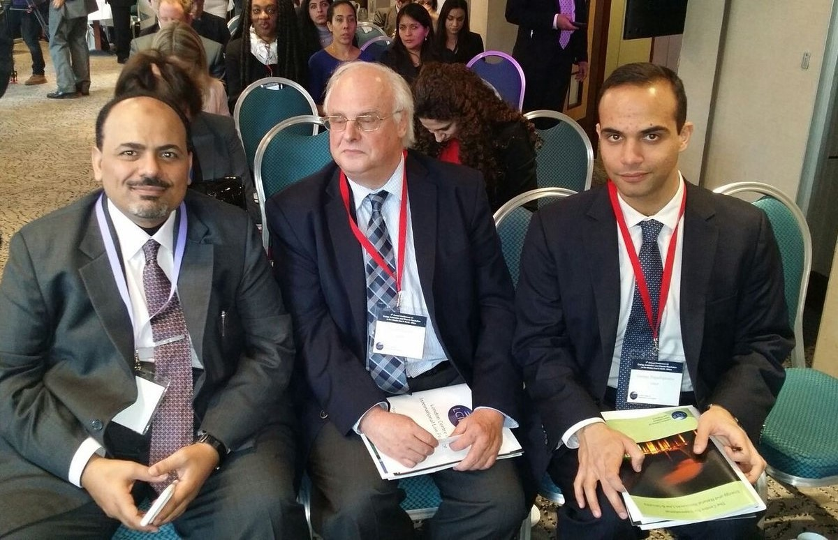
Papadopoulos (far right) at the LCILP’s London conference
The only thing that makes this tale more absurd is that in early March the newly employed Baby George let go of another random stab at getting hired by the Trump organization, perhaps based on his belief that his barren resume had now been bolstered by his gig with the LICLP, which ended in May of 2016 in any event.
This time he got a positive answer, but the manner in which it came about tells you all you need to know about the fact that McCabe, Strzok and Co. did absolutely zero due diligence on Papadopoulos upon the receipt of Ambassador Downer's cable on July 25 and the launch of their investigation shortly thereafter. In fact, their background work was so shoddy that they couldn't have been hired as a detective at the Podunk, Iowa police department.
To wit, during the early months of 2016, when Trump was winning primary after primary against all mainstream media expectations, the Donald's establishment betters began attacking his foreign policy credentials with special malice aforethought.
That was mainly owing to his sensible suggestion that it would be better to seek rapprochement with Russia rather than pursue Hillary's Cold War 2.0; and that 25 years after the disappearance of the Soviet Union from the pages of history the thought occurred to the Donald that perhaps NATO was obsolete and needed to be put out to pasture.
Since this totally plausible (and correct) viewpoint was deeply offensive to the Imperial City's group think and threatened the Warfare State's existential need for a fearsome enemy, Trump's ruminations about making a deal with Putin were roundly belittled---especially by the GOP foreign policy establishment.
Never mind that a fresh look at the realities abroad suggested to the unschooled Trump the possibility that homeland security does not require a global empire. Instead, the fault was said to lie with the candidate's lack of any pedigreed foreign policy advisors.
Indeed, when it came to the Republican-oriented foreign policy establishment---nearly all of which had joined the Never Trump cause----the Donald had recently added insult to injury. That is, he had confessed that he got his foreign policy views watching TV (like most of Washington) and that he could do a better job against terrorism than the Pentagon generals (not hard).
At length, however, the "who are your foreign policy advisors" meme got so relentless that the Donald relented. On March 21, 2016 he announced a group of five advisors that exactly no one who was anyone in the Imperial City had ever heard of, and for good reason.
The group included two recycled DOD flunkies, an anti-Muslim fanatic from the Lebanon religious wars and two kids of no accomplishment in the foreign policy field whatsoever. In a word, the foreign policy establishment's boycott of the Trump campaign at that stage was 100% effective.
Indeed, under a snarky headline the next day about how the new Trump foreign policy team "baffles GOP experts", Politico laid on the disdain good and hard:
“I don’t know any of them,” said Kori Schake, a research fellow at Stanford University’s Hoover Institution and a former official in the George W. Bush State Department. “National security is hard to do well even with first-rate people. It’s almost impossible to do well with third-rate people.”
In this context, Politico made short shrift of young Mr. Papadopoulos and properly so. This wholesome young man had no more qualifications to be named among the top five foreign policy advisors to the then near-presumptive GOP nominee than anyone else in the DC phone book. He hadn't finished his schooling until 2011, had held the above mentioned scut-work stints, and had also accomplished this little gem as per Politico:
Papadopoulos' LinkedIn page also boasts about his role at the 2012 meeting in Geneva of the Model U.N. where students debate current issues. It adds that he has "had experience lobbying foreign policy resolutions on Capitol Hill by means of coherent and concise arguments."
Wow!
But the whole Trump advisory committee was from the same kettle of fish. As indicated above, in addition to Page and Baby George, it consisted of an ex-Pentagon bean counter, a washed-up general who had "managed" (not well) the US "occupation" of Baghdad in 2003-2004 and Walid Phares, the Lebanese war veteran who claimed that the Moslem Brotherhood had infiltrated the State Department and was fixing to spread "Sharia law" to the towns and villages of America!
You almost have the impression that the Donald instructed Ivanka and Jared to check out the Mar-A-Logo sandbox for candidates to round out the rooster, when they came up with Baby George. Except the process was even less scientific than that.
According to the Mueller Report, in early March Papadopoulos again lobbed his resume over the LinkedIn transom to Corey Lewandowski. After being shuffled around among the meager staff at Trump Tower, the resume ended up with senior policy advisor, Sam Clovis---who had just been tasked with putting together an advisory team of foreign policy and national security experts to quell the press brouhaha about Trump's reliance on cable TV for advice on these important matter.
What happened next requires direct quotation from Mueller's 13 Angry Democrats because it is too lame to be believed. Yet here it is:
"After receiving Papadopoulos' name from Lutes, Clovis performed a Google search on Papadopoulos, learned he had worked at the Hudson Institute, and believed that he had credibility on energy issues. On March 3,2016, Clovis arranged to speak with Papadopoulos by phone to discuss Papadopoulos joining the Campaign as a foreign policy advisory and on March 6,2016 the two spoke. Papadopoulos recalled that Russia was mentioned, and he understood that Russia would be an important aspect of the Campaign's foreign policy. At the end of the conservation, Clovis offered Papadopoulos a role as a foreign policy advisor to the Campaign and Papadopoulos accept the offer.
Here's the thing. McCabe & Co. could have readily learned all of this with a few phone calls in late July, and even they would have been hard pressed to describe this as a Trump campaign maneuver to enlist an agent to engage in nefarious dealings with the Russians.
Still, for want of doubt, apparently, the Mueller Report supplies no less than four footnotes to prove exactly nothing.
Thereafter, the greatest nothing-burger imaginable unfolds. In mid-March Papadopoulos traveled to Rome to attend a conference at another shadowy outfit called the Link Campus University that had some sort of relationship with Joseph Mifsud, who was also a professor at the latter. There Papadopoulos met Mifsud for the first time, who promised to introduced him to his extensive set of European and Russian policy and business contacts.
A week or so later in London, Papadopoulos meet again with Mifsud, who this time was accompanied by a Russian female named Olga Polonskaya, who claimed to be Putin's niece. The latter promised to help Baby George make contacts in Russia and to introduce him to her friend, the Russian Ambassador in London.
Following this London meeting, Papadopoulos dashed off an email to Trump HQ that shows his real modus operandi. Said he,
I just finished a very productive lunch with a good friend of mine, Joseph Mifsud...who introduced me to both Putin's niece and the Russian Ambassador in London---who also acts as the deputy foreign minister".
Except. Except.
Baby George had only met Mifsud a week earlier, Polonskaya was not Putin's niece and he never did meet with the Russian Ambassador.
The only meeting of substance he ever had was actually the photo op with the Donald and his new advisory committee. At the meeting on March 31, Baby George did aver that upon his return to London he would be seeking to contact some Russians who might know Putin, which they Donald thought might be interesting, but Senator Jeff Sessions not so much.
Thereafter absolutely nothing happened. Even the "dirt" he jabbered to Ambassador Downer about was with reference to the missing 30,000 emails from Hillary's bleach-washed server that were now more than four years old. The rest of it was a long unanswered string of emails to Trump Headquarters than no one responded to, as we will cover in Part 3.

